

PO Leap
User’s Guide

A Health Quest Inc. Product
Copyright © 2007 Health Quest Inc.

Table of Contents
Table of Contents 2
Part I 4
Introduction 4
Starting Up 4
Program Icons 4
Workgroup Administrator 4
Compact/Repair Icons 4
PO Leap Icon 5
PO Leap Help 5
Getting Started 6
Initial Setup 6
Ongoing Steps 6
Part II 7
Program Definitions and Fundamentals 7
Buttons 7
Fields 7
Filters 7
Part III 9
Main Menu 9
Purchase Orders 10
Purchase Order Detail 15
Non PO Expenses 16
Non PO Expenses Detail 18
Budget 20
Purchase Items 21
Purchase Items: Report Creation 22
PO/Budget Reports 23
Suppliers 26
Part IV 28
Facility Options Menu 28
PO Authorization 29
Account Codes 31
Software Options 32
Budget Setup 32
Security 33
Tax Types 38
Departments 38
Option Menus 39
Sort Options Menu 39
Report Options 39
Table of Exhibits 40

Part I

Introduction
Purchase Order Leap is a software program designed to record and to tracks facility’s purchase orders. The program includes a budget component which allows the users to compare their purchases against their facility’s budget to provide a real-time snapshot of their cost control effectiveness by account code and department.

Starting Up
To open the program, move the cursor on top of the PO Leap icon and double-click. You will now need to supply your "NAME" and "PASSWORD;" click OK. Remember that your password is case sensitive; if your password is in uppercase letters, you must key it in that way.
When the hourglass appears, it is a sign that the computer is processing a series of instructions. Do not click the mouse or press any keys while the hourglass is running; the computer will remember these entries and attempt to execute them.

Program Icons
During PO Leap installation, the program creates an icon group that helps manage your new program. Double clicking on an icon carries out the instructions associated with that icon. For example, double clicking on the PO Leap icon will open PO Leap. The program group contains the following five icons: PO Leap, Workgroup Administrator, Repair PO Leap, Repair PO Leap Data, and PO Leap Help.

Workgroup Administrator
This icon allows the user to join a different workgroup or create a new workgroup. Double clicking on the icon opens a dialog box that shows the user where the program’s system database is located.

Workgroup
A workgroup is a group of users in a multi-user, networked environment who utilize the same data and the same system database.

System Database
A system database is a database file that contains the security and system options for the program. This file is usually called “system.mda”. [Note: Since all of your users should be in the same workgroup, this icon should only be used if the program cannot locate your system database (usually “system.mda”)].

Compact/Repair Icons
Over time, as the user makes changes to the program, file storage can become fragmented. Compacting the program repairs the program making the database program smaller and often results in improved performance. For these reasons, it’s important to compact your program periodically. Sometimes, if there is a power failure, program crash, or the user simply turns off the computer without exiting properly; the program database can become corrupted. If the database becomes corrupted enough, the users will not be able to access the program. Double clicking on the Repair PO Leap Data compacts and repairs the data, while the Repair PO Leap compacts and repairs the data manipulation objects. (Typically, it’s the data that is most likely to become fragmented or corrupted.)

PO Leap Icon
Double click this icon to open PO Leap. Enter your name and password, and then click OK. Remember that your password is case sensitive - if your password is in uppercase letters, you must key it in that way.

PO Leap Help
Double clicking this icon will display the Help Contents of the on-line help file. Within the program, this help file is context sensitive (meaning the Help File will open to the topic that the cursor is resting upon) and can be accessed by pressing the F1 key at any time. The PO Leap help file provides an easy way to discover how different pieces of the PO Leap program work. Clicking on a highlighted or underlined word or phrase in the Help File then will jump you to that particular topic. You can use the SEARCH feature to search for a particular topic for information. The BACK button sends the user back to the last topic he/she accessed in the current help session. The History button displays a list of all topics viewed in the current help session in the order accessed. To jump back to the Help Contents, click on the Contents. You can print a topic by using the File pull down menu, or learn how to use on-line help and its features by using the help menu. Click the CLOSE button to exit help.

Getting Started
Once PO Leap has been installed, use this section as a guide to setting the program up for your facility.

Initial Setup
1. Complete Software Options.
2. Enter your facility’s departments through the “Departments” form
3. Set up your Security. Create the user accounts for each staff member who will be using the program with special attention to their department access.
4. Enter your facility’s Chart of Accounts. Each account code must be assigned a department.
5. Enter the facility’s tax types.
6. Setup the current year’s budget through the “Budget Setup.”

Ongoing Steps
- Enter purchase orders.
- Enter budget information.
- Check and authorize purchase orders and send batched to corporate.
- Enter any expense/purchases not handled by a purchase order through “Non PO Expenses.”

Part II

Program Definitions and Fundamentals

Buttons
Throughout the program, you will encounter gray rectangles called “buttons” (see Exhibit 1.) Each of these buttons corresponds to a form, report or particular operation. You can open the form or report or perform the desired operation by moving your mouse to place the arrow on the button, and clicking once.
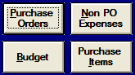
Exhibit 1: Buttons

Fields
Throughout PO Leap, you will encounter fields (see Exhibit 2.), which allow you to enter information into the program. To enter information you simply move the cursor to the desired field and click with your mouse; a cursor will appear and you can type in the space provided.
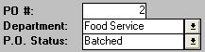
Exhibit 2: Fields
Some fields provide a list box (distinguished with a down arrow to the right of each white rectangle, Exhibit 2). List boxes allow you to select from an already existing list of possible entries. In Exhibit 2, the field “Department” is a list box; you select from the choices provided when you click on the arrow. “PO #” is an example of a default field; the program supplies a probable entry, in this case the next numerical PO number, but allows you to change the entry.

Filters
Filters are categories by which you can limit data presented in a report. To initiate a filter, click on the circle to the left of the filter option; a list box will appear. Now click on the down arrow and highlight the specific filter criteria you want to use with the cursor and click again. Once you have selected the filter criteria, click on the FILTER button to refine the report. For example, on the “Purchase Orders Detail” form, all purchase orders are listed. You may want to view only the Administration purchase orders whose po status is ‘ordered’; you can do so by selecting the filter ‘Department’ and highlighting the item ‘Administration’ and the filter ‘PO Status’ and selecting the item ‘Ordered.’ Then click the FILTER button. To view all records again, click the UNFILTER button. Several filters can be used in combination to further limit the data viewed.

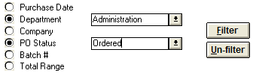
Exhibit 3: Filters

Part III

Main Menu
The main menu screen opens when you enter the program. The Main Menu is comprised of the six primary purchase order forms and reports. Each of the six rectangular gray buttons on the Main Menu corresponds to a form or report. Click on the gray buttons to open specific forms and reports. You can exit the program by clicking on the EXIT PURCHASES button. Only users belonging to the coordinators security group can access the Facility Options Menu which allows the coordinator(s) to enter general information about the facility required by the program.

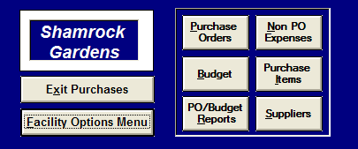
Exhibit 4: Main Menu

Purchase Orders
With this form you will define and complete your facility’s purchase orders. The Purchase Order form is divided into three main sections: top, middle, and bottom. The top section contains the purchase order #, department, po status, search list, and buttons. The middle section contains the bulk of your purchase order entry: vendor info, invoice # and date, purchaser and date, and the individual purchase order items. The bottom section consists mainly of the purchase order totals: account code total, purchase order subtotal/total, tax, shipping/handling, discount, and comments.
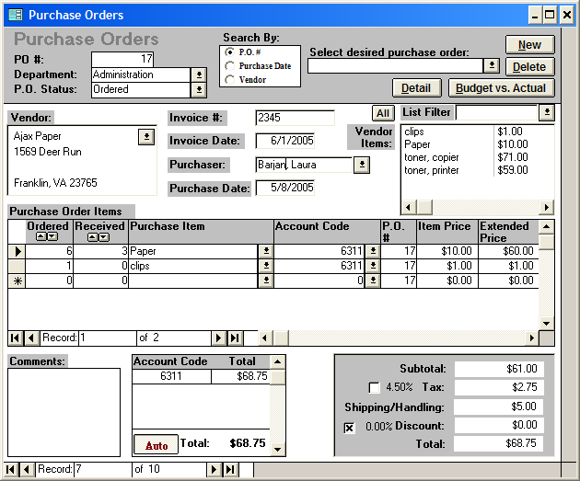
Exhibit 5: Purchase Orders

Purchase Orders: Top Section
By default, the form goes to the first purchase order upon opening.
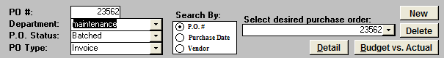
Exhibit 6: Purchase Orders: Top Section
Purchase order #: Each new purchase order is automatically assigned purchase order #. This number will be one greater than the highest purchase order number previously assigned. You cannot use the same purchase order # for two different purchase orders; each PO # must be unique. You can change the purchase order number to whatever number you wish, as long as the number is unique.
Department: Select the department associated with the purchase order. You will only be able select departments for which you have security permission. You will only be able to create, edit, and view purchase orders for which you have departmental permission. These permissions are assigned through the “Security“ form which can be accessed through the “Facility Options Menu.” Required field.
PO Status: Select the current status of the purchase order. You may only choose from two status options in the Purchase Order form: Ordered or Received. You select the ordered status when the purchase has been contracted but the goods have not been received. Once the goods are delivered the status should be updated to Received. This is a very important field. Your purchase order totals and calculations will be based upon the po status. When the status is ordered, the extended price in the purchase order items subform is calculated by multiplying the item price by the number in the ordered field. Conversely, when the po status is received, the received field is utilized in the extended price calculation. The two other po status options, Authorized and Batched, can only be selected through the “Purchase Order: Authorization” and “Assign Batch Number” forms respectively. Once the po status is either authorized or batched, the purchase order cannot be edited through the “Purchase Order” form. Required field.
PO Type: Each new purchase order is automatically assigned invoice as the PO type by default. You use invoice for normal POs where you are submitting a PO for payment for goods and/or services received. The other PO type you can select is credit memo. You should utilize credit memo only when a credit needs to be applied to vendor. The purchase order total for a credit memo is always negative, while an invoice is always positive.
Select desired purchase order: By clicking the down arrow to the right of this box, the user may review a list of existing purchase orders. To view or edit an existing purchase order: select the desired item from the box, place the cursor on the desired purchase order and click once. You can change how the search box is sorted by selecting one of the three “Search By” options (purchase order #, purchase date, or vendor).
NEW: Clicking this button supplies user with a blank form to add a new purchase order. You define the purchase order by supplying necessary information in the designated fields.
DELETE: Clicking this button allows the user to delete a purchase order from the program. The delete function permanently removes that work order from the program and should be used only for mistakes. You cannot delete purchase orders that have a po status of authorized or batched. Do not delete old purchase orders just because they have been completed.
DETAIL: Clicking this button opens the “Purchase Order Detail” form which includes all the purchase orders entered through the “Purchase Orders” form. Instead of reviewing a single po this form allows you an overview of your entire facility’s purchase orders. Through the filter options and Sort Options menu, you are able to filter and sort your purchase orders in a myriad of ways.
BUDGET VS. ACTUAL: Clicking this button opens the “Monthly Actual and Budget Purchase Report.” This report compares the budgeted amounts allocated to a department’s account codes against the purchase order and non po expenses incurred for those accounts. Basically this report reveals whether a given department is under or over budget for a selected month and year to date.

Purchase Orders: Middle Section
The middle section contains the bulk of your purchase order entry: vendor info, invoice # and date, purchaser and date, and the purchase order subform with your individual purchase item info.
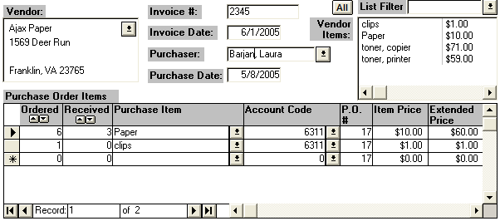
Exhibit 7: Purchase Orders: Middle Section
Vendor: Select the desired vendor/supplier for the purchase from the list box. The vendor’s address will automatically appear if this info has been entered through the “Suppliers” form. If the desired vendor is not listed or needs to be edited, choose the ‘Add New/Edit’ item from this list to open the “Suppliers” form, which allows you to create or edit supplier/vendor information. The selection of a vendor controls the vendor items box. Then vendor items box lists any of the purchase items purchased previously through the selected vendor.
Invoice #: Enter the invoice number.
Invoice Date: Enter the invoice date.
Purchaser: Enter the person initiating the purchase order from this list of the facility’s current employees. Required field.
Purchase Date: Enter the date the purchase order is contracted. The current date/time is entered automatically by default. The purchase order portion of the Purchases vs. Budget reports is based on this date. Required field.
Vendor Item: This is a list of the purchase items which have been purchased previously from the selected vendor. This list box is the most efficient way to add purchase items to the po. Clicking on the desired purchase item from this list, automatically adds it to the purchase order items. Clicking on the same item more than once increases the ordered field by one for each click. The list filter drop down box filters the purchase items by the item type selected. Click the ALL button to unfilter the list and show all purchase items.
Purchase Order Items: This subform contains the details of the purchase order—its purchase order items. It contains the following fields: ordered, received, purchase item, account code, po #, item price, and extended price.
Ordered: Enter the number of a specific purchase item ordered. When the po status is ordered, the extended price in the purchase order items subform is calculated by multiplying the item price by the number in this field. The up and down arrows in this field heading, add or subtract one from the ordered number respectively for each arrow click.
Received: Enter the number of a specific purchase item actually received. When the po status is received, the extended price in the purchase order items subform is calculated by multiplying the item price by the number in this field. The up and down arrows in this field heading, add or subtract one from the received number respectively for each arrow click.
Purchase Item: Enter each of the purchase items you intend to acquire. The most efficient way to accomplish this is to click on the desired purchase item from the vendor list. If the item is not in the vendor list, choose the desired item from the purchase item drop down list box. If the purchase item is not in the purchase item list or the item needs to be edited (for example its price updated), select “Add New/Edit” from the drop down list box to open the “Purchase Items” form. In this form you can add new purchase items or update old ones. After making your additions/changes and you close the “Purchase Items” form, make sure you change the purchase item on “Purchase Orders” from “Add New/Edit” to the desired purchase item.
Account Code: This field should be automatically filled when the purchase item is selected either by clicking po items from vendor items or selecting an item fro the purchase order drop down list. If the account code is incorrect for the po item, you can change it through the drop down list but you should also correct it in the “Purchase Items” form or this mistake will keep occurring. Required field.
PO #: Automatic field which reflects the po #, entered in the po # field in the top section.
Item Price: The purchase item’s price per unit. This field should be automatically filled when the purchase item is selected. If the item price is incorrect for the po item, you can manually change it in this field but you should also update it in the “Purchase Items” form or this mistake will keep occurring.
Extended Price: Cost of the purchase item--calculated field no entry required. When the status is ordered, the extended price is calculated by multiplying the item price by the number in the ordered field. Conversely, when the po status is received, the received field is utilized in the extended price calculation.

Purchase Orders: Bottom Section
The bottom section consists mainly of the purchase order totals: account code total, purchase order subtotal/total, tax, shipping/handling, discount, and comments.
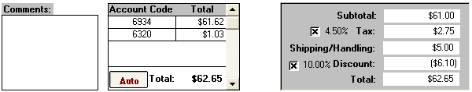
Exhibit 8: Purchase Orders: Bottom Section
Comments: Utilize this field to enter any additional information about the purchase order. These comments will appear on the “Purchase Orders Batch Report” that is sent to corporate.
Account Code Total Box: This small important subform breaks out your purchase order total into its component account codes and totals. These account codes and totals reflect the information you have entered in the purchase order. When the AUTO button is engaged (reads Auto), the account code totals will be automatically calculated and updated as you make changes/additions to your purchase order. This AUTO setting is the one you will use the majority of the time and makes your life easier. Nevertheless, in some cases you must manually override the automatic account calculations. For example, sometimes you will have purchase items that are taxed at different rates. The AUTO setting spreads the tax amount to each account code based on the percentage of each account code to the total po. Therefore, with different tax rates the AUTO setting will spread the account totals incorrectly. In this case, you must disengage the AUTO toggle button by clicking on it which changes it MANUAL. Then you must manually enter the appropriate total amounts for each account code. Clicking the MANUAL button again returns it to the AUTO setting. Remember the account code total must match the purchase order total.
Subtotal: Sum of the purchase items’ extended prices--calculated field no entry required.
Tax: This field calculates the total tax for the purchase order. The tax rate is determined by the selected vendor (if the tax rate is incorrect for the vendor, correct in the “Suppliers” form). There is a check box to the left of the tax field. If the check box is ‘X’ed, then the tax will be automatically calculated by multiplying the tax rate (rate between check box and tax field) times the subtotal. If you need to manually override the tax field (for example, purchase items have different tax rates), un’X’ the check box and manually enter the desired amount in the tax field.
Shipping/Handling: Enter the cost of shipping and handling.
Discount: This field calculates the total discount for the purchase order. The discount rate is determined by the selected vendor (if the discount rate is incorrect for the vendor, correct in the “Suppliers” form). There is a check box to the left of the discount field. If the check box is ‘X’ed, then the discount will be automatically calculated by multiplying the discount rate(rate between check box and discount field) times the subtotal. If you need to manually override the discount field (for example, discount only applies to part of the po), un’X’ the check box and manually enter the desired amount in the discount field. Remember discounts are reflected by a negative number.
Total: Total cost of the purchase order: subtotal + tax + shipping/handling + discount--calculated field no entry required. Remember the account code total must match this field.

Purchase Order Detail
To open this form, click on the DETAIL button in the “Purchase Orders” form. “Purchase Order Detail” includes all the purchase orders entered through the “Purchase Orders” form. Instead of reviewing a single po this form allows you an overview of your entire facility’s purchase orders. You will only see those purchase orders for which you have departmental security clearance. Through the filter options and Sort Options menu, you are able to filter and sort your purchase orders in a myriad of ways. This form contains the following fields:
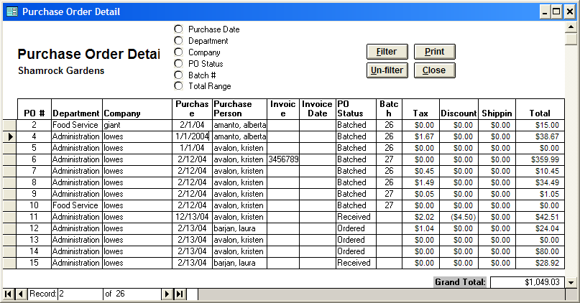
Exhibit 9: Purchase Order Detail

PO #: unique number used to identify a purchase order.
Department: the specific department associated with the work order.
Company: the vendor/supplier with who you placed a purchase order.
Purchase Date: the date the purchase order is contracted.
Purchase Person: the person who initiated the purchase order.
Invoice #: the po’s invoice number.
Invoice Date: the po’s invoice date.
PO Status: current status of the PO: ordered, received, authorized, or batched.
Batch #: the number of the batch the po was assigned went sent to corporate.
Tax: the po’s tax amount.
Discount: the po’s discount amount.
Shipping: the po’s shipping/handling amount.
Total: the total amount of the purchase order.

Filter Options
The filter options provide an efficient way to extract specific information from the purchase orders. To initiate a filter, click on the option button () to the left of the desired filter selection which open a list of choices. (For example, choosing the po status option opens a list of all your po status options). Next, select the desired item from the list. Then you can either choose another filter selection to refine your list even more, or process the records with the current selection by clicking the FILTER button. For example, suppose you wanted to know which Food Service purchase orders cost between $100 and $500. Simply click the department option button and choose ‘Food Service’ from the list. Next, choose the total filter and enter a range of 100 to 500. Pressing the FILTER button reduces the purchase orders to food service orders costing between $100 to $500. Click the UNFILTER button to show all the purchase orders again. The print out will list how the report has been filtered. The form contains the following filters:

Purchase Date Range: enter the date range you wish to filter for.
Department: list contains all the departments entered in the “Departments” form.
Company: list of suppliers from the “Suppliers” form, which allows you to create or edit the suppliers/vendors.
PO Status: list of po status options: ordered, received, authorized, or batched.
Batch #: enter a batch number.
Total: enter a number range in dollars to filter by the PO total.
You can print the “Purchase Order Detail” by clicking the PRINT button or close it by clicking the CLOSE button. This form allows the use of the Sort Options Menu.

Non PO Expenses
With this form you enter any expense/purchases not handled by a purchase order--for example, your employee salaries or facility’s electric bill. Entering these non po expenses will help you get a better understanding of your cost and budget controls. The amounts entered here are included with purchase order amounts in the Purchases vs. Budget reports. This form contains the following fields:
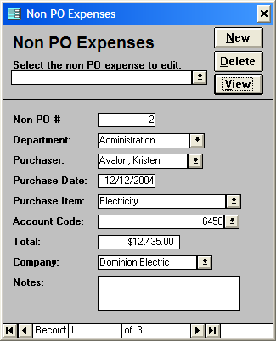
Exhibit 10: Non PO Expenses

Select the non po expense to edit: By clicking the down arrow to the right of this box, the user may review a list of existing non po expenses. To view or edit an existing non po expenses: select the desired item from the box, place the cursor on the desired expenses and click once.
NEW: Clicking this button supplies user with a blank form to add a new non po expense. You define the expense by supplying necessary information in the designated fields.
DELETE: Clicking this button allows the user to delete a non po expense from the program. The delete function permanently removes that expense from the program and should be used only for mistakes. Do not delete old non po expenses just because they have been completed.
VIEW: Clicking this button opens the “Non PO Detail” form which includes all the non po expenses entered through the “Non PO Expense” form. Instead of reviewing a single expense this form allows you an overview of your entire facility’s expenses. Through the filter options and Sort Options menu, you are able to filter and sort your expenses in a myriad of ways.
Non PO #: Each new non po expense is automatically assigned a non po # once you have entered data into this form. You cannot edit this field.
Department: Select the department associated with the expense. You will only be able select departments for which you have security permission. You will only be able to create, edit, and view non po expenses for which you have departmental permission. These permissions are assigned through the “Security“ form which can be accessed through the “Facility Options Menu.” Required field.
Purchaser: Enter the person initiating the non po expense from this list of the facility’s current employees. Required field.
Purchase Date: Enter the date purchased. The current date is entered automatically by default. The non po expense portion of the Purchases vs. Budget reports is based on this date. Required field.
Purchase Item: Enter the purchase items you intend to acquire. If the purchase item is not in the purchase item list or the item needs to be edited, select “Add New/Edit” from the drop down list box to open the “Purchase Items” form. In this form you can add new purchase items or update old ones. After making your additions/changes and you close the “Purchase Items” form, make sure you change the purchase item on “Non PO Expenses” from “Add New/Edit” to the desired purchase item.
Account Code: Select the desired account code from the drop down list. Required field.
Total: the cost of the expense. Required field.
Company: Select the desired vendor/supplier for the expense from the list box. If the desired vendor is not listed or needs to be edited, choose the ‘Add New/Edit’ item from this list to open the “Suppliers” form, which allows you to create or edit supplier/vendor information.
Notes: Utilize this field to enter any additional information about the expense.

Non PO Expenses Detail
To open this form, click on the VIEW button in the “Non PO Expenses” form. “Non PO Expenses Detail” includes all the expenses entered through the “Non PO Expenses” form. Instead of reviewing a single expense this form allows you an overview of your entire facility’s expenses. Through the filter options and Sort Options menu, you are able to filter and sort your expenses in a myriad of ways. This form contains the following fields:
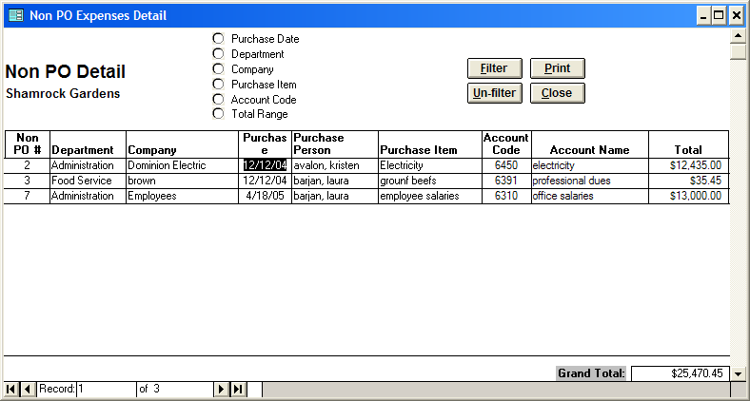
Exhibit 11: Non PO Detail
Non PO #: unique number used to identify a non po expense.
Department: the specific department associated with the expense.
Company: the vendor/supplier with whom you incurred the expense.
Purchase Date: the date of the expense.
Purchase Person: the person who initiated the non po expense.
Purchase Item: the item received.
Account Code: the account code associated with the expense.
Account Name: the name of the account associated with the expense.
Total: the total amount of the non po expense.

Filter Options
The filter options provide an efficient way to extract specific information from the non po expenses. To initiate a filter, click on the option button () to the left of the desired filter selection which opens a list of choices. (For example, choosing the company option opens a list of all your vendors/suppliers). Next, select the desired item from the list. Then you can either choose another filter selection to refine your list even more, or process the records with the current selection by clicking the FILTER button. For example, suppose you wanted to know which Administration expenses cost between $1000 and $5000. Simply click the department option button and choose ‘Administration’ from the list. Next, choose the total filter and enter a range of 1000 to 5000. Pressing the FILTER button reduces the expenses to admin expenses costing between $1000 to $5000. Click the UNFILTER button to show all the expenses again. The form contains the following filters:

Purchase Date Range: enter the date range you wish to filter for.
Department: list contains all the departments entered in the “Departments” form.
Company: list of suppliers from the “Suppliers” form, which allows you to create or edit the suppliers/vendors.
Purchase Item: list of purchase items from “purchase Items” form.
Account Code: list of account codes from the “Chart of Accounts” form.
Total Range: enter a number range in dollars to filter by the PO total.
You can print the “Non PO Expense Detail” by clicking the PRINT button or close it by clicking the CLOSE button. This form allows the use of the Sort Options Menu.

Budget
With this form you can enter your budgeted amounts for each account code for the designated budget year. By utilizing the Purchases vs. Budget reports, this budget information can then be compared to the actual expenses incurred (purchase orders and non po expenses) to measure the effectiveness of your facility’s cost controls. The OPEN PRINT button opens the “Budget Datasheet” form which allows you to print your budgets by clicking the PRINT button. Users that have full permissions for all departments can now print out a budget datasheet for all departments at once, instead of only by department. This form contains the following fields:
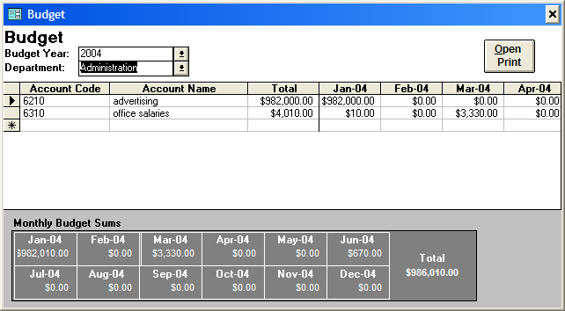
Exhibit 12: Budget

Budget Year: Select from the pull down list box the budget year you wish to enter budget info for. The budget year is a 12 month period created and defined through the “Budget Setup” form accessed from the “Facility Options Menu.”
Department: Enter the specific department you wish to budget for.
Account Code: Enter the account codes you wish to budget for. These codes can be created and edited through the “Chart of Accounts” form.
Account Name: the name of the account associated with the account code. Automatically entered when the account code is selected.
Total: Calculated field that reflects the total amount budgeted for the account code for the budget year. Sum of the 12 individual budgeted months.
Monthly Budget Amounts: Enter the budgeted amount for each month for each account code.
Monthly Budget Sums: Budget Totals by month for a specified department.

Purchase Items
In this form you can create new purchase items or update old ones. You can access this form by clicking the PURCHASE ITEMS button from the “Main Menu” or by choosing the “Add New/Edit” item from the purchase items field on the “Purchase Orders” form or the “Non PO Expenses” form. This form contains the following fields:

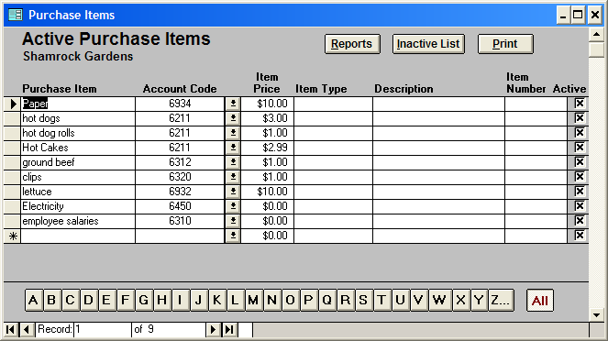
Exhibit 13: Purchase Items
Purchase Item: Enter an item your facility wishes to purchase. If you later change the name of the purchase item, the name will be updated in the purchase orders and non po expenses where you previously entered the purchase item.
Account Code: Enter the account codes associated with the item. These codes can be created and edited through the “Chart of Accounts” form.
Item Price: The purchase item’s price per unit.
Item type: Enter the general category to which the purchase item belongs. The list filter on “Purchase Orders” uses item types to filter purchase items in the vendor items box.
Description: Enter any additional useful info about the item here.
Item Number: Enter the purchase item’s number, if applicable.
Active: When you wish a purchase item to no longer be included in your current purchase item lists in “Purchase Orders” and “Non PO Expenses,” un’X’ the item’s active box. Clicking the INACTIVE LIST toggle button, shows the list of inactivated purchase items, clicking the toggle button again shows the list of active purchase items.
The alphabetical filters at the bottom of the form filter out only those purchase items beginning with the letter of the button that you click on. The ALL filter shows all the purchase items. The PRINT button prints out this form, while clicking the REPORTS button opens the “Purchase Items: Report Creation” form described in detail below.

Purchase Items: Report Creation

This report allows the user to create four different purchase item reports over a user defined date range based on the data entered in the “Purchase Orders” form. These reports are extremely useful in determining things such as price volatility and supplier price hikes. You can choose to create one of the following four reports:

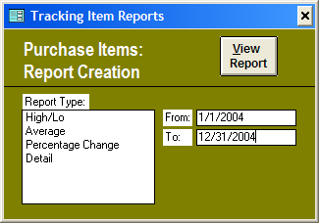
Exhibit 14: Purchase Items: Report Creation

High/Lo: This report details the high and low number prices entered for a purchase item over the specified date range and the percentage change between these prices. You can filter this report by purchase item.
Average: This report details the average price entered for a purchase item over the specified date range. You can filter this report by purchase item.
Percentage Change: For the specified date range, this report lists the first entry date, first price, last entry date and the last price; computing the percentage change from the difference of the first and last entered prices. You can filter this report by purchase item.
Detail: This report details all the individual purchase items over the specified date range. The fields shown are po #, purchase item, department, company, purchase date, purchase person, account code, quantity order, quantity receive, item price, and extended price. You can filter this report by po range, purchase item, department, company, account code, and item price range.
After selecting the desired report type and entering the desired date range, clicking the VIEW REPORT button creates the appropriate report. On these reports, pressing the FILTER button reduces the records to whatever filter options you have selected. Click the UNFILTER button to show all the records again. Closing the reports returns you to “Purchase Items: Report Creation.” Closing this form exits the user to the “Purchase Items” form.

PO/Budget Reports

Clicking this button from the “Main Menu” opens the “Purchases vs. Budget” form. This form provides two reports: each report compares the budgeted amounts allocated to a department’s account codes against the purchase order and non po expenses incurred for those accounts. Basically these reports reveal whether a given department is under or over budget for a selected month and year to date or an entire budget year. To open the “Monthly Actual and Budget Purchase Report,” specify the desired budget year, budget month, and department, then click the VIEW REPORT button. Similarly, to open the “Yearly Actual and Budget Purchase Report,” specify the desired budget year and click the VIEW REPORT button. Pressing CANCEL returns you to the “Main Menu.”

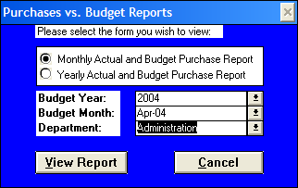
Exhibit 15: Purchases vs. Budget Reports

Monthly Actual and Budget Purchase Report: This report compares purchase orders, non po expenses, and budget amounts for a specified month and department. The monthly budget vs. actual field subtracts your actual expenses (purchase orders and non po expenses) from the budget, your anticipated expense. A negative number means that you are over budget, a positive one--under budget. The YTD budget vs. actual field is calculated the same way except the actual and budget amounts are totaled for the entire budget year through the specified month, instead of just the specified month. To run this report for a different department, simply select the new desired department in the department pull down list. Remember you can only select those departments for which you have security permission. Clicking on the CHANGE MONTH button, will return you to the Purchases vs. Budget Reports form where you can rerun this report for a different budget year, month, and/or department. The PRINT button prints this report.

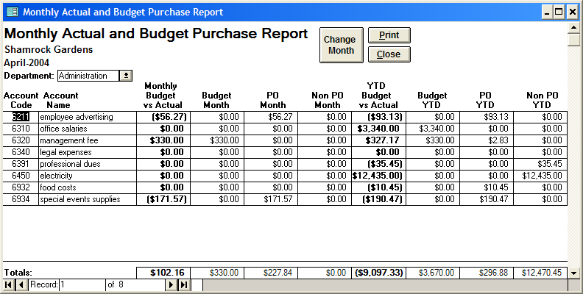
Exhibit 16: Monthly Actual and Budget Purchase Report

Yearly Actual and Budget Purchase Report: This report breaks out purchase orders, non po expenses, and budget amounts for each month and department for the selected budget year. This report provided an excellent overview for the entire budget year instead of just a specific month. The budget vs. actual field subtracts your actual expenses (purchase orders and non po expenses) from the budget, your anticipated expense. A negative number means that you are over budget, a positive one--under budget. Utilize the Report Options menu in the upper left corner of your screen to print or close this report.

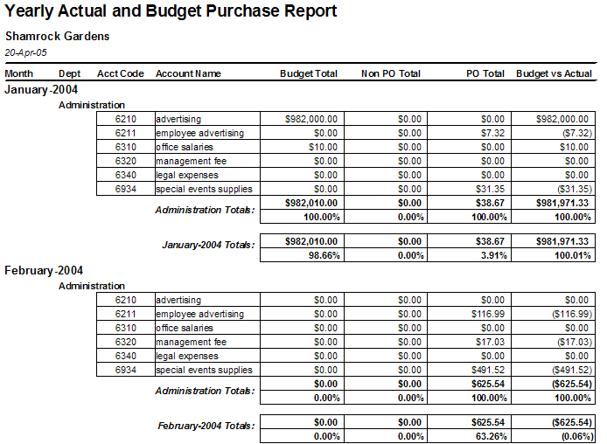
Exhibit 17: Yearly Actual and Budget Purchase Report

Suppliers

With this form you can enter the information about your supplier/vendors. This form can be accessed from the “Main Menu” or by selecting ‘Add New/Edit’ in the vendor and company fields in the “Purchase Orders” and “Non PO Expenses” form respectively. Press the NEW button to go to a blank record to enter the pertinent information of a new supplier. On the other hand, to edit or review an existing supplier, select the item from the ‘Select the desired company’ drop-down list or scroll to the desired supplier. The VIEW button allows you to view and/or print a complete list of your suppliers. This form contains the following fields:

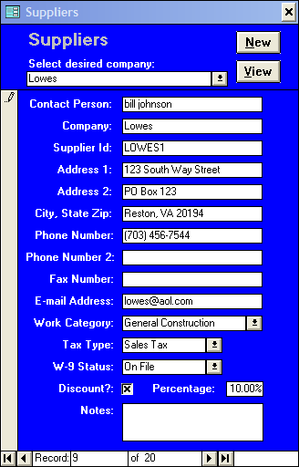
Exhibit 18: Suppliers
Contact Person: Enter the contact person.
Company: Enter the name of the supplier.
Supplier ID: Enter a unique id that identifies the supplier.
Address 1: Enter first line of address.
Address 2: Enter second line of address.
City, State Zip: Enter city, state, and zip code.
Phone Number: Enter supplier’s phone number.
Phone Number 2: Enter supplier’s secondary phone or cell number.
Fax Number: Enter supplier’s fax number.
E-mail Address: Enter supplier’s e-mail address.
Work Category: Choose from a list of general categories (such as Carpentry or Plumbing) used to categorize your suppliers. Choosing the ‘Add New/Edit’ item from this list opens the “Work Categories” form, which allows you to create or edit your work categories.
Tax Type: Enter the supplier’s tax type. Choosing the ‘Add New/Edit’ item from this list opens the “Tax Types” form, which allows you to create or edit your tax types. The tax type selected sets the default tax rate when this supplier is selected in the “Purchase Orders” form.
W-9 Status: Select the supplier’s W-9 status. Choose from On-file, requested, or unnecessary.
Discount?: Mark this box if the supplier gives your facility a standard discount on purchases.
Discount Percentage: Enter the supplier’s discount percentage if applicable. The percentage entered sets the default discount rate when this supplier is selected in the “Purchase Orders” form.
Notes: Enter any additional info concerning the supplier.

Part IV

Facility Options Menu
This menu allows the coordinator(s) to enter general information about the facility required by the program. These forms should be completed before operating the program because many of the forms in PO Leap require this information. [Note: You will not be able to access this menu without the appropriate security permissions.]
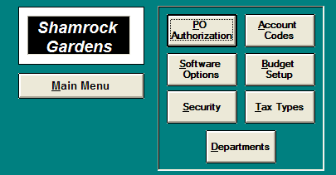
Exhibit 19: Facility Options Menu

PO Authorization
This form allows you to complete a final review of the purchase orders entered by your facility’s staff. The form lists all the purchase orders with a po status of ordered, received, or authorized. PO Authorization contains all the same fields of information as the “Purchase Orders” form in a more compact package. The authorizer opens this form and reviews each purchase order, correcting any errors. Once a purchase order meets your approval, click the button to the right of the po status field. This action will change the po status to “Authorized” and enter the user as the approval person. Once the po status becomes authorized, changes cannot be made to the po through the “Purchase Orders’ form (changes can still be made through this form, including changing the po status).
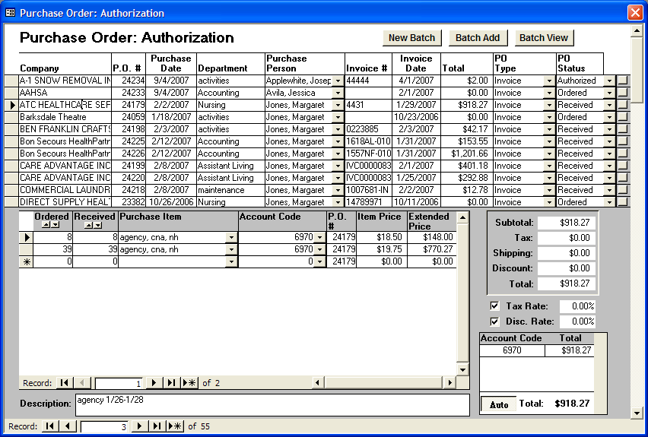
Exhibit 20: Purchase Order: Authorization
Once the selected purchase orders have been authorized, your next step is to batch the authorized purchase orders to send to corporate. First click the NEW BATCH button to open the “Assign Batch Number” form. Opening this form will automatically create a new batch number. The batch date is today’s date by default but can be edited. The purchase orders you have previously authorized in the “Purchase Order: Authorization” form will be listed on this form. Any of the authorized purchase orders you wish to send to corporate in this designated batch, click on the button to the right of the po status. This action will change the po status from ‘authorized’ to ‘batched.’ Batched purchase orders will no longer appear in the “Purchase Order: Authorization” form but can be viewed through the “Batch View” form. If you wish to add authorized purchase orders to an already existing batch number, click the BATCH ADD button. The authorized purchase orders will appear on the “Assign Batch Number” form. Simply choose the desired batch number from the batch # drop down list, this will add the po to the specified batch and change the po status to ‘batched.’

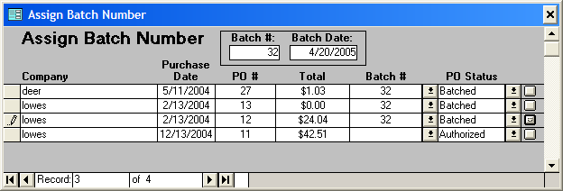
Exhibit 21: Assign Batch Number
To review and print a purchase order batch, click on the BATCH VIEW button. This opens the “Batch View” form. Utilize the batch number drop down box, to select the batch number you wish to view. To remove a po from a batch, simply change the po status. Click the PREVIEW button to preview the “Purchase Orders Batch Report.” The PRINT button prints a summary po batch report and individual po batch reports for each purchase order.
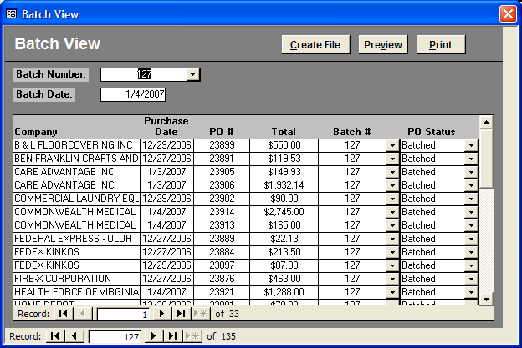
Exhibit 22: Batch View
Pressing the CREATE FILE button on the “Batch View” opens the “Create Batch File” form which allows you to create a file for the selected batch that you e-mail to CSM, so they can import your POs directly into their accounting system. Simply enter the path and name of the batch file you wish to create and then push the CREATE FILE button. A standard naming convention would be to use the first four letters of your facility’s name followed by the batch number with the .txt file extension. The file will not be created if your path does not exist. There is no need to save these batch files after you send them to CSM, since you can always recreate a batch file if necessary.
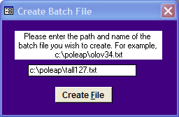
Exhibit 23: Create Batch File

Account Codes
This form allows you to enter and edit your facility’s chart of accounts which are utilized through this program. Press the NEW button to go to a new, blank record to enter a new account code. This form contains the following fields:
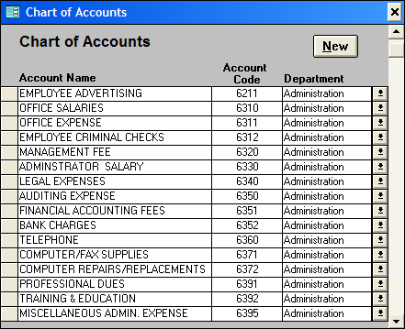
Exhibit 24: Chart of Accounts
Account Code: Enter the account code.
Account Name: Enter the name of the account associated with the account code.
Department: Enter the department associated with the account code.

Software Options
This form allows the coordinator to specify some general info for the PO Leap program. Enter the requested information.
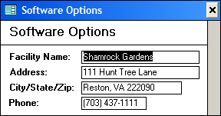
Exhibit 25: Software Options

Budget Setup
This form allows you to create and define your budget years. To create a new budget year, click the NEW button which takes you to a new, blank record. Enter the name of budget year. Select the month in which you wish the budget year to begin from the start month drop down box. Next, enter the year in which you wish the budget year to begin in the start year field. Once you click out of the start year field, the twelve month fields will automatically be filled based on your start month and year.

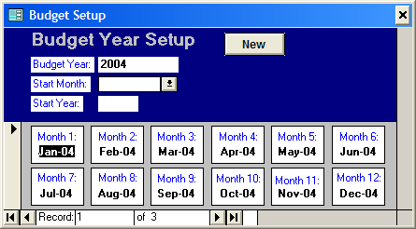
Exhibit 26: Budget Year Setup

Security
This form, accessed through the “Facility Options Menu,” allows the coordinator to set PO Leap’s security. User security determines access to PO Leap and its objects. A user name and password are required each time the program is opened.
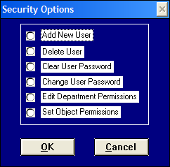
Exhibit 27: Security Options

Add New User
The "Add New User" form allows the user that belongs to the coordinators group to create a new account for a new user. Specify the following information:
Employee Name: Enter the person from this list of the facility’s current employees whose user security account you wish to create.
New User Name: An alphanumeric string that identifies each user account. Any combination of letters and numbers can be used in this field, including the new user’s name.
User Group: Identifies both the type of a user and the permissions granted to that user; choose from “Coordinators”, “Supervisors” and “Staff.” For example, users who belong to a group the coordinators group are allowed to create new accounts and delete old ones, but users that belong to other groups are not allowed to add or delete accounts.
Personal Identifier (PID): A case-sensitive alphanumeric string 4-20 characters long that Leap To uses to distinguish each user in a Workgroup. This identifier can be the same as the user name or the password, but needs to be unique to each user. For example, if two Jennifers work at your facility, both can have the user name “Jennifer”, but they should have different PIDs and passwords.
New Password: A case-sensitive alphanumeric string used for logging into the database. Passwords should contain at least five characters and be easy to remember but difficult to guess. Keeping the password private prevents a security breach and makes tracking much easier.
Verify: Confirms a new password by prompting you to retype the alphanumeric string you have just created.
Access all departments: ‘X’ this box if you want the user to have access to all the facility’s departments’ information (purchase orders, non po expenses, etc.) Dept. access subform disappears when marked because it is then unnecessary.
Dept. Access: Enter in this subform the department(s) for which the created user will have access. Dept. access subform disappears when access all departments is ‘X’ed because it is then unnecessary.
After the fields are completed, click OK and the new account will be created. Click CANCEL to exit the form without creating a new account. After a new account is created, the new user will be able to login to the program with the new user name and password.
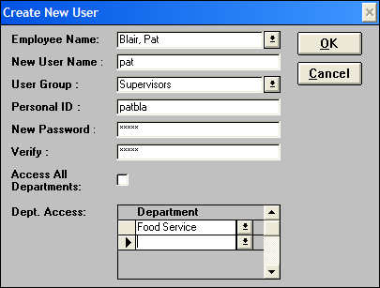
Exhibit 28: Create New User

Delete User
"Delete User" allows a coordinator to delete a user account. To delete a user account, choose a user name from the drop-down list and click OK. Click CANCEL to exit without deleting a user. [Note: Once a user is deleted, the user name, PID, group, and password cannot be retrieved.]
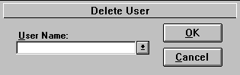
Exhibit 29: Delete User

Clear User Password
The "Clear User Password" form enables the users that belong to the coordinators group to clear a user password of a user. This is used in case the user(s) forgot his or her password and wants to regain access to PO Leap. The coordinator can then clear the password through this form and then create a new password for the user through the “Change Password” form.
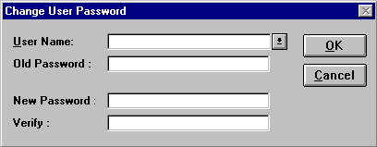
Exhibit 30: Clear User Password
Choose a user name from the drop-down list and click the CLEAR PASSWORD button. Click CANCEL to exit the form without clearing the password. Once the password is cleared, the user (or the coordinator) should enter a new password by utilizing the “Change User Password” form. By reducing the number of no-password accounts, the system maintains a higher level of security.

Change User Password
This form allows the coordinator to change a password to a user account. Enter the old password, then enter the new password and verify it. If a new password is being entered to replace a password that has been cleared (see above), then leave the “Old Password” field blank. Click the OK button to accept the new password. Click CANCEL to exit the form without saving your changes. Passwords should have at least five characters (letters or numbers), which prove easy to remember but difficult to guess.
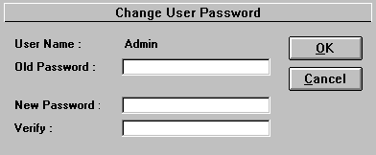
Exhibit 31: Change User Password
Use the Change User Password feature as often as you like. The password is like a key; it’s the user's responsibility to keep that key safe.

Edit Department Permissions
This form allows the coordinator to edit a user’s department permissions. First, choose a user name from the drop-down list. ‘X’ the access all departments box if you want the user to have access to all the facility’s departments information (purchase orders, non po expenses, etc.) Conversely, if you want the user to access only select departments do not mark this box. Instead enter in the department permissions subform the department(s) for which the created user will have access. This subform disappears when access all departments is ‘X’ed because it is then unnecessary.

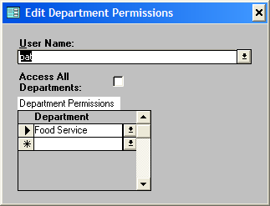
Exhibit 32: Edit Department Permissions

Set Object Permissions
This form allows members of the coordinators group to set object permissions for each menu object.

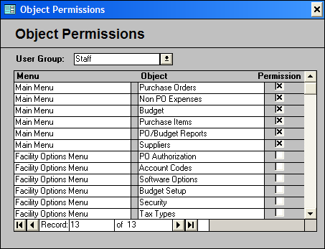
Exhibit 33: Object Permissions
Select a user group from the drop-down list box and click an “X” in the permission boxes of those menu objects you want the selected user group to be able to view. Conversely, unmark the permission boxes of those menu objects you do not want the selected user group to view.

Tax Types
This form allows you to create or edit your tax types. Press the NEW button to go to a new, blank record to enter a new tax type. Your suppliers/vendors will be associated with one of these tax types. This form contains the following fields:

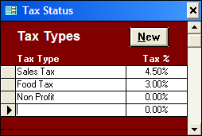
Exhibit 34: Tax Types
Tax Type: Enter the name of the tax.
Tax Rate: Enter the tax type’s tax rate.

Departments
This form allows you to create or edit your departments. Press the NEW button to go to a new, blank record to enter a department. Departments in conjunction with account codes are the key components which organize PO Leap.

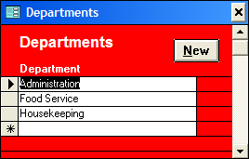
Exhibit 35: Departments

Option Menus
Many of PO Leap’s forms and reports support Sort Options and Report Options menus. These option menus appear at the top left-hand corner of most continuous forms (forms showing a list of records instead of one record at a time). To access these menus, click on the menu heading, choose the desired option from the menu, then point and click with your mouse. The two types of menus and their commands are explained below:

Sort Options Menu

Sort Ascending
Sort the records of the current field in ascending order (alphabetically or numerically). For example, in the “Purchase Order: Authorization” form, click anywhere in the “Department” column, click on Sort Options, and select Ascending Order. All records in this form will be sorted in ascending alphabetical order by “Department.”

Sort Descending
This will sort the records of the current field in descending order (alphabetically or numerically). For example, in the “Purchase Order: Authorization” form, click anywhere in the “Total” column, click on Sort Options, and select Descending Order. All records in this form will be sorted in descending order by total.

Copy
This command will copy the selected text to the Windows clipboard, which can be later retrieved using the Paste command in this or another Windows application. This command is utilized when the user wants to copy information to another place within the program or to export selected information to another application. To select the data you wish to copy, click the left mouse button and hold it down as you drag the cursor over the desired text. Release the mouse button when all the desired text has been highlighted and click the Copy command.

Paste
This command will take the text previously copied onto the Windows clipboard and paste it into the currently selected location. This command saves the user from having to retype the same information into another application.

Help
Clicking Help will display the program’s context-sensitive help file, which will open on the topic that your cursor rests on. For example, you can press the Help command on “Purchase Orders”, and the help file will pop up with information concerning this form. You can also access this command by pressing the F1 key.

Report Options

Print
Clicking this command will print the current report.

Close
Clicking this command will close the current report.

Table of Exhibits
Exhibit 1: Buttons 7
Exhibit 2: Fields 7
Exhibit 3: Filters 8
Exhibit 4: Main Menu 9
Exhibit 5: Purchase Orders 10
Exhibit 6: Purchase Orders: Top Section 11
Exhibit 7: Purchase Orders: Middle Section 12
Exhibit 8: Purchase Orders: Bottom Section 14
Exhibit 9: Purchase Order Detail 15
Exhibit 10: Non PO Expenses 17
Exhibit 11: Non PO Detail 19
Exhibit 12: Budget 20
Exhibit 13: Purchase Items 21
Exhibit 14: Purchase Items: Report Creation 22
Exhibit 15: Purchases vs. Budget Reports 24
Exhibit 16: Monthly Actual and Budget Purchase Report 24
Exhibit 17: Yearly Actual and Budget Purchase Report 25
Exhibit 18: Suppliers 26
Exhibit 19: Facility Options Menu 28
Exhibit 20: Purchase Order: Authorization 29
Exhibit 21: Assign Batch Number 30
Exhibit 22: Batch View 30
Exhibit 23: Create Batch File 31
Exhibit 24: Chart of Accounts 31
Exhibit 25: Software Options 32
Exhibit 26: Budget Year Setup 32
Exhibit 27: Security Options 33
Exhibit 28: Create New User 34
Exhibit 29: Delete User 34
Exhibit 30: Clear User Password 35
Exhibit 31: Change User Password 35
Exhibit 32: Edit Department Permissions 36
Exhibit 33: Object Permissions 37
Exhibit 34: Tax Types 38
Exhibit 35: Departments 38

